Exam of Digital Communications
a.a. 2019-2020
Feb 03, 2020

Exercise #1
The spectrum of a lowpass signal is shown below:
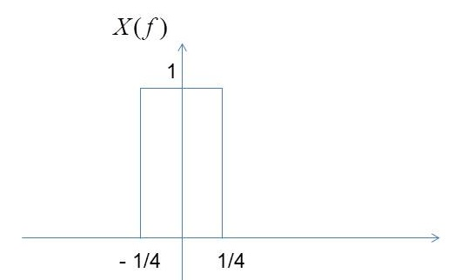

- Determine the value of the Nyquist sampling rate, fs,min.
- Sketch the ideal sampled spectrum Xδ(f), for the sampling rate fs = 2fs,min
- Sketch the spectrum of the complex envelope of the output of an ideal (rectangular) bandpass filter with f0 = 2, B = 0.6, and gain 1/4.
Solution
- From Figure, B=1/4. The Nyquist sampling rate is 2B=1/2
- Spectrum of the sampled signal
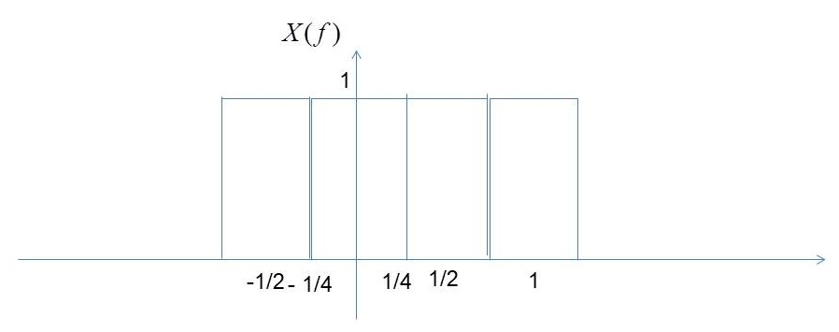
Spectrum of the complex envelope of the filtered signal
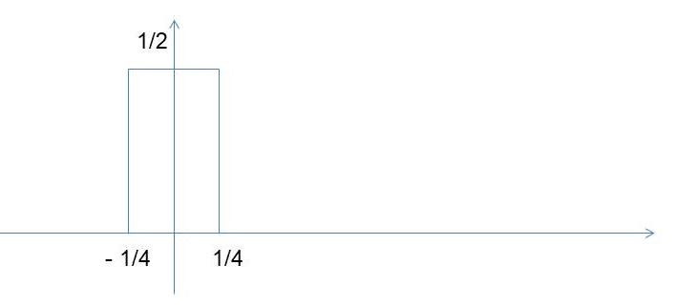

Exercise #2
A message signal m(t) is transmitted by binary PCM. Let the signal to-quantization noise (SQNR) required be at least 46 dB. Determine the minimum number of bit required to encode each sample, assuming that m(t) is sinusoidal. With this value of quantization levels, determine the SQNR.
Solution
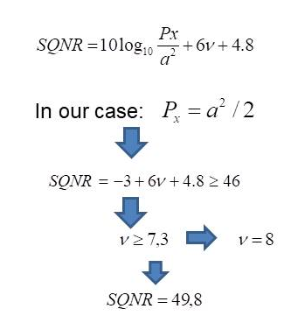

Exercise #3
The two pulses shown in the figure below are employed in a binary signaling
scheme to be used in a digital communication system with AWGN channel with noise energy N0/2.
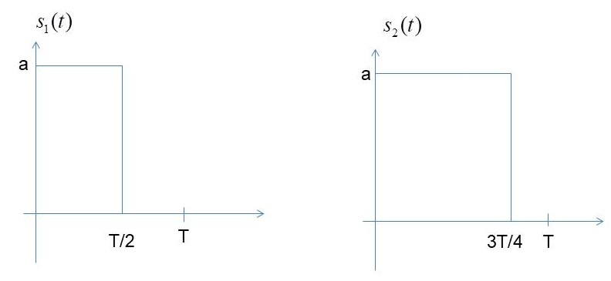

- Calculate the average energy per bit
- Sketch carefully the optimum receiver (and the impulse response of the filters are included in the receiver).
- Write the expression of the probability of error as a function of the energy per bit
- Compare the achieve probability of error with the probability of error of an antipodal binary transmission scheme with the same energy per bit

Solution
- Eav=Eb (one symbol is one bit in this case)=0.5*E1+0.5*E2
E1=(T/2)*a^2
E2=(3T/4)*a^2
Eb=(5T/4)*a^2
- First of all, let us represent the two pulses as a linear combination of orthonormal independent pulses. It is easy to see that the two orthonormal pulses are the following.

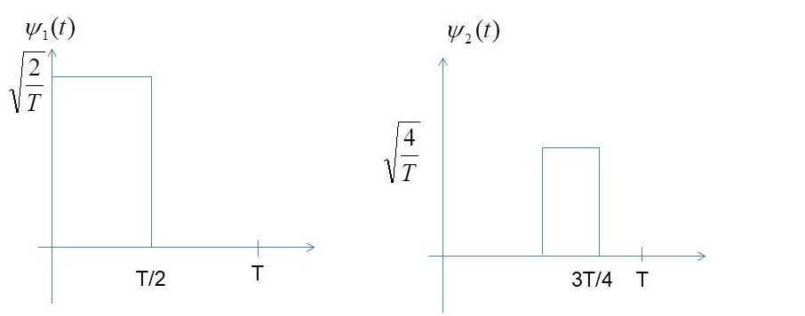
The related matched filters are:

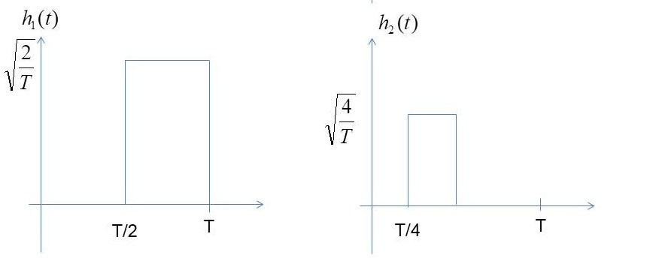

The optimum receiver is:
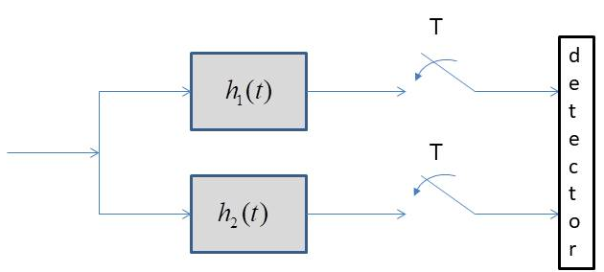
(c ) –(d) Given that the two original pulses can be written as a function of the orthonormal basis:
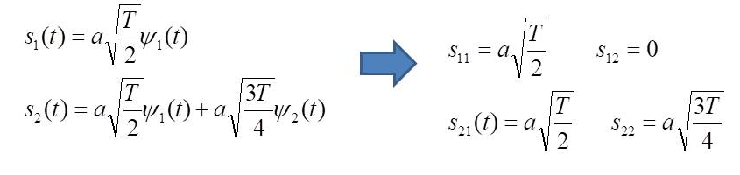
The constellation is:
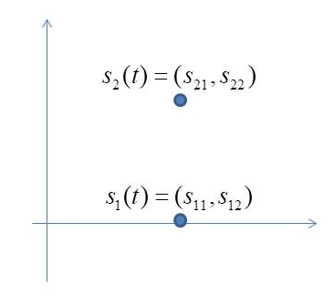
In a binary system, the BER can be expressed as a function of the distance d between the two points of the constellation:
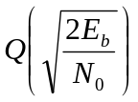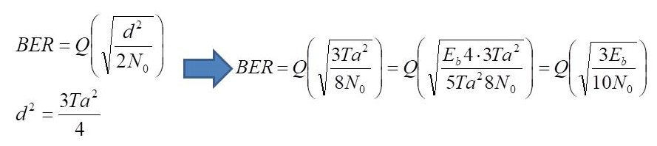
This probability of error is much higher the the probability of error of an antipodal binary system, which is:

Exercise #4
A bandpass QPSK modulation system uses the following orthonormal signals:

The noise is AWGN with N0 = 1 and the target probability of a bit error is Pb = 10−5.

- Determine the maximum bit rate of the system (bps)
- The channel bandwidth is 450Hz and a raised cosine spectrum is employed to eliminate ISI. Determine the excess bandwidth and sketch carefully the spectrum
- Draw the constellation points

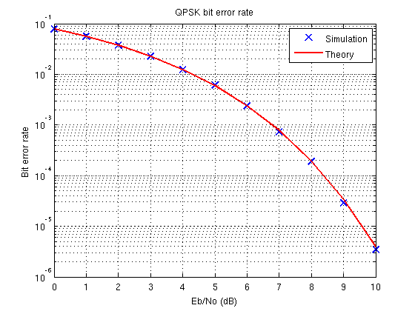

Solution
